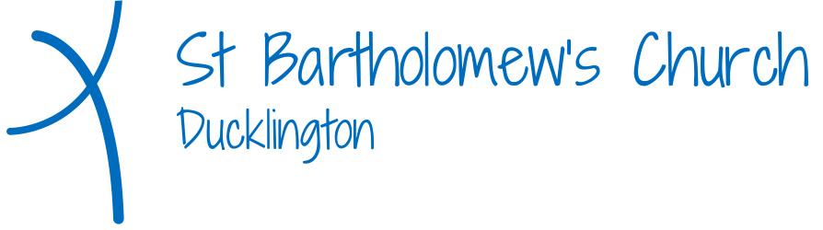

Men’s Group Visit to The Classic Motor Hub
Friday July 25th 2025

Name____________________________________________________________________

Email____________________________________________________________________

Contact Phone Number___________________________________________________

Are you happy to give others a lift in your car?______________________________

Do you require Transport?_________________________________________________

£5 attached

